ECOTOURIST VISITORSHIP BEHAVIOUR IN NATIONAL PROTECTED AREAS (PA)
2016
(January to December 2016)
- TOTAL 2016 VISITORS
Table 1 and Chart 1 show the number of 2016 tourists to open protected areas in the National Natural Parks System (NNPS), as well as their behaviour in comparison to 2014 and 2015.
Table 1
Tourists visiting PA during 2014, 2015 and 2016
2014 | 2015 | 2016
917.146 | 969.792 | 1’446.716

- Variation from 2015 to 2015: increased by 49.2%
- Variation from 2014 to 2016: increased by 57.7%
PA Tourists Behaviour in 2014, 2015 and 2016
Chart 1
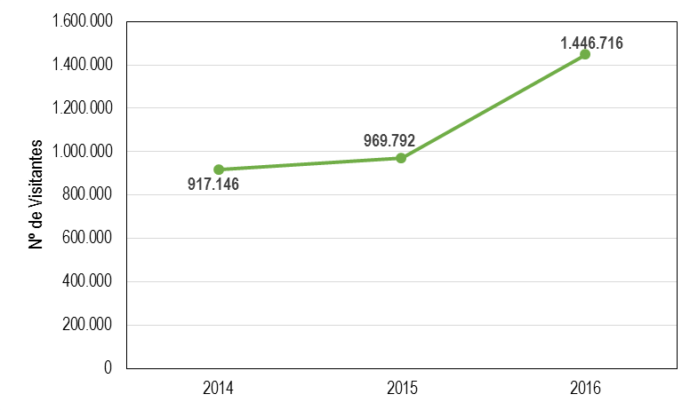
The total number of visitors in 2016 was 1’446.716 which represents a 49% increase from the 2015 figures, and of 57% compared with 2014 figures, owing mainly to the increase in visitors to the two most visited areas. Thus, the Natural National Park (NNP) Corales del Rosario and San Bernardo saw an 89% increase in visitors, taking into consideration the land entrance to the Playa Blanca-Baru sector, for a total 846.164 visitors. The NNP Tayrona saw a 17% increase in visitors with a total 391.442 visitors. Notwithstanding the foregoing, it must be stated that the elevated percentage increase accounts for the visitors who entered by land the Playa Blanca-Baru sector, which had not been considered in 2015, having nonetheless increased significantly due to the construction of the bridge leading to the zone, while also diminishing the number of visitors departing from the La Bodeguita pier.
It is important to remember that some ecotourism protected areas are partially or totally closed to the public for several reasons, as follows: The NNP Amacayacu is closed since March 2012 due to the damage caused to the visitor center by the 2012 and 2014 floods. The NNP Los Nevados is only partially open since January 2013, as far as the Valle de las Tumbas zone due to volcanic activity. However, despite not being fully available, the park saw a 22% increase in visitors compared to 2015 results. The NNP Gorgona is open only to researchers since April 2015, daypass tourists, and tourists entering in diving boats. In any case, the contract awarding for the full service rendering has been expedited, set to begin in mid-February 2017. Additionally, the NNP Cocuy is closed since March 2016, and the Unique Natural Area (UNA) Los Estoraques is closed due to dangerous conditions to visitors on the La Virgen trail. Finally, despite the visiting season to the NNP Sierra de La Macarena – Caño Cristales goes from June to December, visitor access was restricted since 15 November due to the hot season and the diminishing of water resources that affected the Macarenia clavijera plant.
The foregoing confirms the constant increase of ecotourists to the PA since 2004 due to the positioning of ecotourism in the PA both domestically and internationally, as well as to the ongoing strengthening of ecotourism executed through the syndication by PARQUES, with the support of official government institutions, such as the Tourism Underministry, Procolombia and FONTUR which foster tourism in Colombia and abroad; to the promotion undertaken by community organizations, community ecotourism operators, and the Tayrona Concession. Moreover, the tourists’s consumer reports detailing their good experiences, per the satisfaction surveys. In addition to this, there is a growing interest amongst consumers in ecotourism which includes as an added value a component of social and environmental responsibility, as well as the actions started to improve the quality of ecotourism services in the protected areas, the updating of service information in the communication media made available by PARQUES, the participation in showcases such as ANATO, and the interest of community and private operators to divulge the PA ecotourism service and activity offer.
HISTORIC QUARTERLY BEHAVIOR OF PROTECTED AREAS OPEN TO THE PUBLIC DURING 2013, 2014 AND 2015.
The following chart shows the behaviour of the number of visitors for the four quarters of 2014, 2015 and 2016, where an increase is evident.
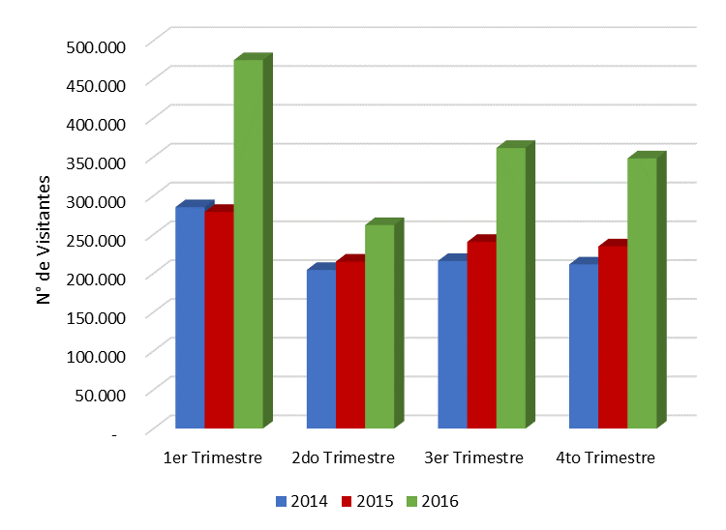
Chart 2

  - MOST VISITED ECOTOURISM AREAS
These were the most visited ecotourism areas during 2016
Protected Area | Number of Visitors
NNP Corales del Rosario | 846.164
NNP Tayrona | 391.442
NNP Nevados | 39.904
FFS Isla de la Corota | 38.905
NNP Old Providence | 25.076
NNP Chingaza | 23.248
NNP Sierra Nevada | 21.117
NNP Sierra de la Macarena | 14.325
FFS Flamencos | 10.637

The following chart shows the percentage participation of the Protected Areas by number of visitors in 2016.
Most Visited Protected Areas in 2016
Chart 3
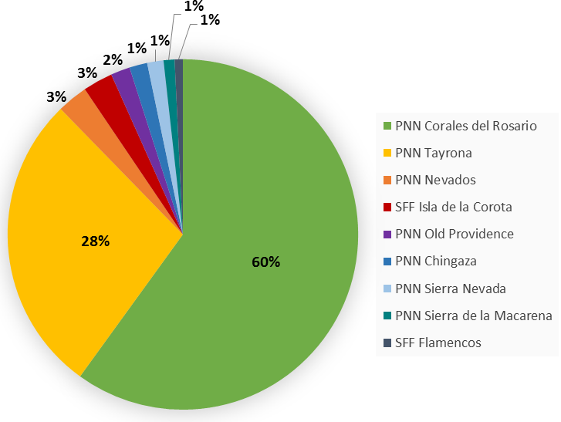

From the above data, it is clear that the most visited PA are located in the Caribbean region (NNP Corales del Rosario y San Bernardo, and NNP Tayrona) followed by the parks located in the Andean region (NNP Isla de la Corota, NNP Nevados and NNP Chingaza) (See Table 2), thus keeping 2015 behaviour.
Number of ecotourists visiting PA by regions in 2016
Table 2
TERRITORIAL AUTHORITY (TA) | Number of visitors
ORINOQUIA TERRITORIAL AUTHORITY | 37.913
AMAZONIA TERRITORIAL AUTHORITY | 0
NORTH EASTERN ANDES TERRITORIAL AUTHORITY | 14.992
WESTERN ANDES TERRITORIAL AUTHORITY | 86.735
CARIBBEAN TERRITORIAL AUTHORITY | 1.297.975
PACIFIC TERRITORIAL AUTHORITY | 9.101

Charts 4, 5, 6, 7 and 8 show the number of visitors to PA open to the public by Territorial Authorities in 2016
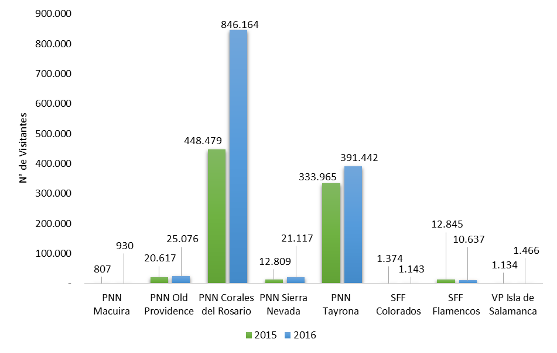
Visitor Access to PA in the Caribbean region
Chart 4

Visitor access to PA in the Pacific region
Chart 5
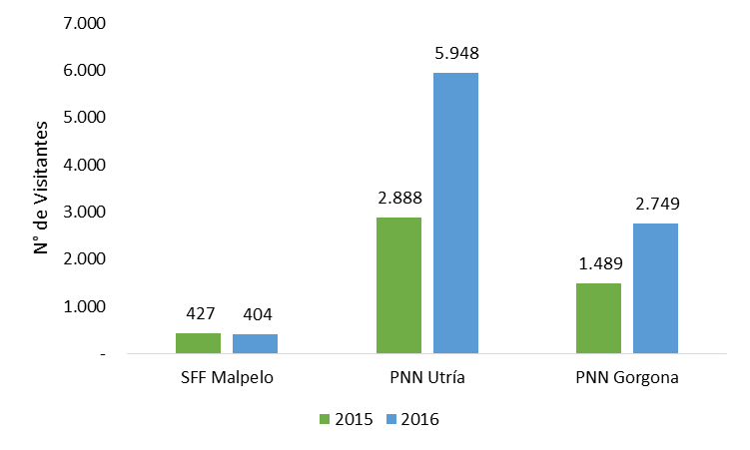

Chart 6
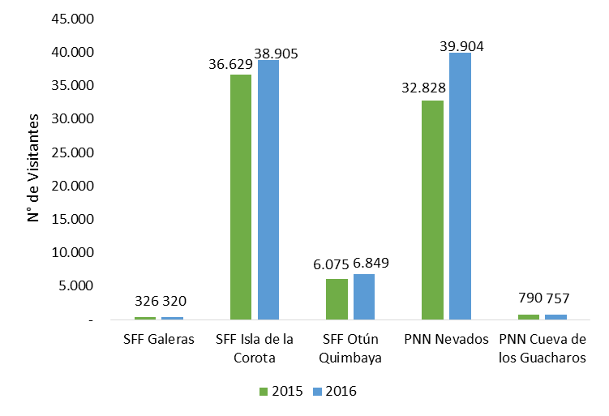

Visitor access to PA in the Western Andes region
Chart 7
Visitor access to PA in the North Eastern Andes region
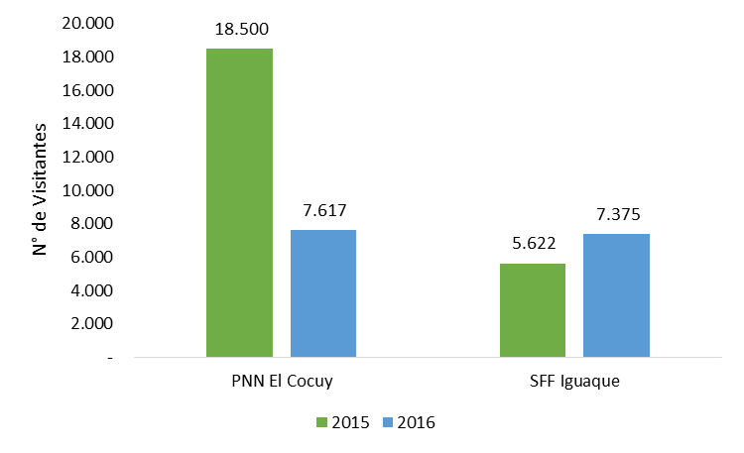

Visitor access to PA in the Orinoquia region
Chart 8
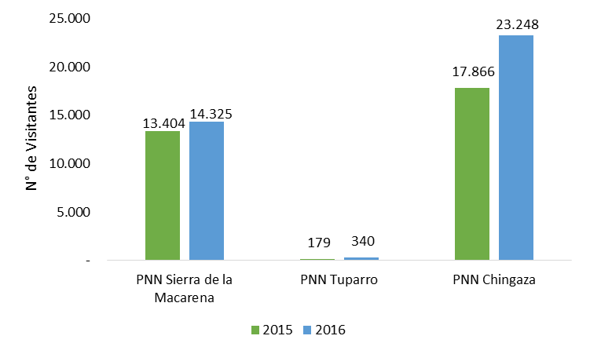

  - COMMUNITY ECOTOURISM VISITOR BEHAVIOUR
Number of visitors to PA with Community Ecotourism programs in 2015 and 2016
Tabla 3
Protected Area | 2015 | 2016 | Variation
NNP Chingaza | 17.866 | 23.248 | 30%
NNP Corales del Rosario | 448.479 | 846.164 | 89%
NNP Cueva de los Guácharos* | 790 | 757 | -4%
NNP El Cocuy | 18.500 | 7.617 | -59%
NNP Nevados | 32.828 | 39.904 | 22%
NNP Utría | 2.888 | 5.948 | 106%
FFS Iguaque | 5.622 | 7.375 | 31%
FFS Otún Quimbaya | 6.075 | 6.849 | 13%
General Total | 533.048 | 937.862 | 76%
*The Community Ecotourism Program started in April 2016
The number of visitors to the NNP Chingaza increased by 30% in 2016, keeping its growth from previous years due mainly to syndication and advertising, as well as the undertaking of several different events and activities of the programs Salud Naturalmente en los Parques, and Colegios al Parque. The trend is expected to continue on the rise as a greater number of visitors may arrive thanks to infrastructure improvements, such as on the Suasie and Siecha trails.
The 89% increase in visitorship to NNP Corales del Rosario y San Bernardo in comparison with 2015 is due mainly to visitor control enforced during 2016 by NNP personnel in the Playa Blanca-Baru zone, considering the great increase in visitorship entering the NNP through this road after being repaired, which led to a reduction in the number of visitors leaving through the la Bodeguita pier.
For NNP Cueva de Los Guacharos saw a drop of 4% in visitorship in comparison with 2015, due mainly to the park being closed in February and March because of infrastructure improvements. On 5 April 2015, contracts with the community organizations Andakies and Cerca Viva were signed. The full offer of services is projected to be published soon, along with a marketing plan to increase visitorship.
The NNP El Cocuy saw a 59% drop in visitorship as it has been closed to ecotourism since March 2016 owing to pressure by local community groups. There are at the moment negotiations underway with these groups to reopen the park, which has affected the income to local communities. Nonetheless, when the numbers of visitors who entered the park during the first two months in 2016 is compared with the same period in 2015, there was an upward trend of 13%.
The NNP Utria saw a 106% increase in 2016 compared to 2015, because of its positioning domestically and abroad chiefly due to the whale season; the promotion activities accomplished by the Corporacion Mano Cambiada and other agencies fostered by Procolombia that offer other experiences in the destination other than whale watching, such as gastronomy, ecotourism and cultural contact, among others.
FFS Iguaque saw a 31% increase in visitorship in 2016 compared to the previous year, despite having been closed during the first quarter because of a fire hazard in the protected area. It is important to consider that during the first semester, the protected area operated at half its housing capability, which has since changed and is now operating at full capacity. Visitors are being drawn to the park especially because of the exercise with student groups, in place since the middle of the year. Several academic, technical and cultural exercises in relation with the environment, which have drawn the attention of ecology and environmental engineering students.
At the FFS Otun Quimbaya there was a 13% increase in 2016 compared to 2015, primarily due to the visibility the destination has acquired through interinstitutional alliances, through being included in the trail of the Coffee Cultural Landscape, and through being recognized in 2016 as the only sustainable tourism destination in the country, raking among the top 100 in the world. Besides this, the community organization Yarumo Blanco has been implementing a strategy for three years that has begun to bear fruit. This strategy uses digital tools as a fundamental axis, positioning the sanctuary as a touristic destination. Additionally, consumer reports has furthered the commercial effort, which has yielded financial results visible in the monthly reports. Finally, alliances are being established with many operators to diversify the distribution channels.
Moreover, since mid-2016 the Association has implemented as a policy to have an official permanently on the ecotourism premises. On the other hand bird watching, which is one of the main ecotouristic activities of the sanctuary, has been promoted by the township government, the department government and the underministry and FONTUR.
The NNP Los Nevados saw a 22% increase in visitorship in 2016 compared to 2015, mainly because the Santa Isabel snow peak has been advertised as an ecotourism amenity of this park.
In spite of the positive behavior shown above, certain external conditions affecting activity still require attention in order to continue improving results, such as having better visitorship, lower air rates to the Pacific, completing service infrastructure and visitor control improvements, strengthening promotion and environmental interpretation programs, as well as improving digital marketing and promotion to bring in many more visitors.
  - BEHAVIOR IN PROTECTED AREAS UNDER ECOTOURISTIC SERVICES CONCESSIONS
The following table will show the number of visitors at NNP Tayrona, where ecotouristic services are concession-operated.
Number of visitors to PA with concession-operated ecotouristic services in 2015 and 2016
Table 4
Protected área | 2015 | 2016 | Variation
NNP Tayrona | 333.965 | 391.442 | 17%

The 17% increase at NNP Tayrona is due principally to the national and international positioning of the park, and to the fact that Santa Marta has many tourism destinations, which are marked as must-see locations for tourists.
The operators take tourists to these locations, conveniently found near the park, and this in turn produces increased tourist flow in the area, who are also driven to enter the protected area. An unusual phenomenon has occurred this year, and that is that student groups, both foreign and domestic, have visited the area due to the low rates available to them. For the year end season, several entities have held events and promotions to foster visits to Santa Marta and its amenities, with communication campaigns in mass media.
Lastly, visitor entrance, link implementation, online pre-sale and purchase (www.parquetayrona.com.co) and the sale of entry tickets at Aviatur offices have all been improved.

